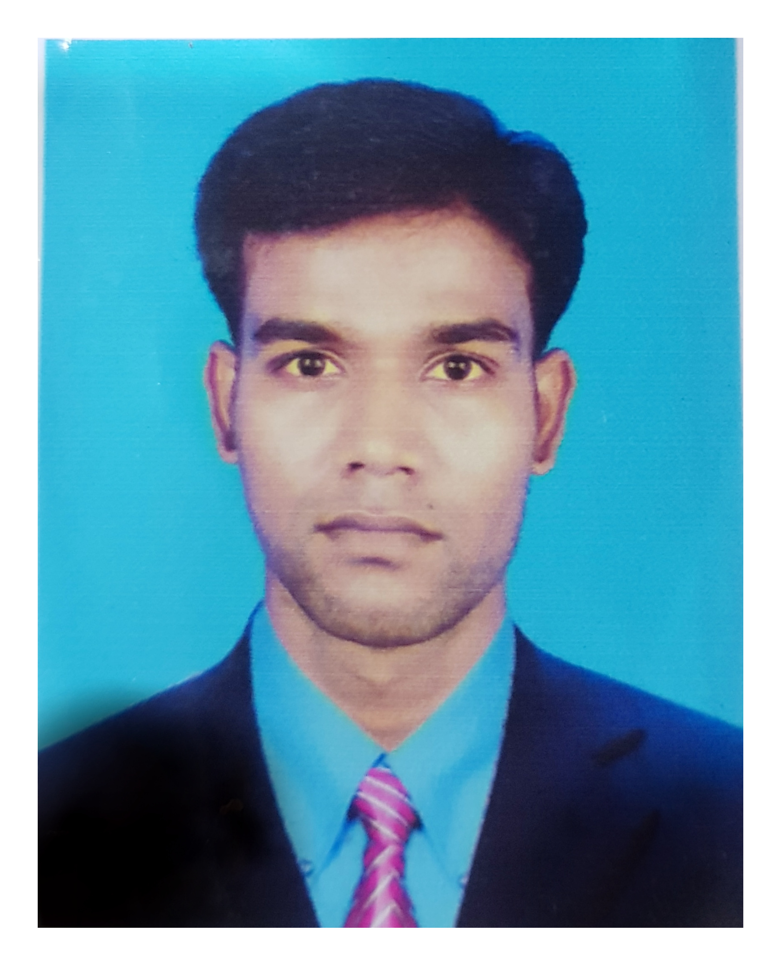**RESUME**

Of

**Md. ABUL KALAM AZAD**

Diploma in Mechanical Technology

[E-mail-akazad10163@gmail.com](mailto:E-mail-akazad10163@gmail.com)

Cell: +8801771438388

**CAREER OBJECTIVE:**

To pursue a challenging position using Engineering and Professional Techniques that will consume my Knowledge, Potential Skills and Excellence in the area of Engineering.

**EDUCATIONAL QUALIFICATIONS:**

**Diploma In Engineering:**

Institution : Jashore Polytechnic Institute, Jashore

Board     : Bangladesh Technical Education Board, Dhaka

Passing year    : 2014

Department     : Mechanical Technology

Result     : C.G.P.A- 3.38 (out of 4.00)

* **Secondary School Certificate (S.S.C):**

Institution : Ichalli  High School

             Board : Jashore

Passing year    : 2010

Group : Humanists

Result : G.P.A- 4.69 (out of 5.00)

**TRAINING SUMMARY:**

* Three months course external industrial attachment,
* Bangladesh industrial Technical Assistance Center (BITAC)
* Sheromoni Bisic Area Khulna.
* Course-co-ordinate & assistance Engineer  Md.Arifur Rahman.
* Course duretion 26/08/2014 to 17/11/2014.

|  |  |  |
| --- | --- | --- |
|  |  |  |

**PERSONAL QUALITIES:**

* + **Highly** self- motivated;
  + Ability to work under pressure.
  + Worker Management .
  + Working in production sector .
  + CNC and NC machine operation.
  + Plc sector working.
  + Automotion system .
  + Operation in robotics system .
  + Various types of machine such as lathe, milling ,cylindrical ,Grinding, Boaring ,drill,machine operation..
  + Weliding expart such as Arc welding ,Tig welding ,Mig welding, Gas Welding .

**PERSONAL DETAILS :**

|  |  |  |
| --- | --- | --- |
| **Name** | : | MD. Abul Kalam Azad |
| **Father,s Name** | : | MD. Abdul Hakim |
| **Mother,s Name** | : | Mst .Nazma Begum |
| **Date of Birth** | : | 10th Octobar 1995 |
| **Gender** | : | Male |
| **Marital Status** | : | Married |
| **Nationality** | : | Bangladeshi (by birth) |
| **Blood Group** | : | B+ |
| **Religion** | : | Islam |
| **Parmanent Address** | : | Village- **Bijoynagor** P.O- **Khujarhat**, P.S- **Kotwali**, Dist. **Jashore** |
|  |  |  |

**LANGUAGE PROFICIENCY:**

Language: Writing:         Reading:           Speaking:

     Bengali: Excellent                   Excellent      Excellent

     English: Excellent   Excellent     Good

**COMPUTER SKILLS***:*

 MS Office, MS Excel ,  Powerpoint ,Auto Cad ,CNC and NC

|  |  |  |  |
| --- | --- | --- | --- |
|  | Experience:  **4 Years Working Experience.**  **Jashore Polytechnic institute, jashore**  **Designation: Jounior Instructor (Part time)**  **Dept: Mechanical Technology**  **Duretion: 15/07/2015-31/01/2019**  **2 Years Working Experience.**  **Designation: Engineer (Producton) .**  **Duretion: 10-02-2019 – Continuing)**  **Uttara Motors Limited**  **(Trans Asia Industries Ltd.)**  **(An Enterprise of Uttara Group of Companies)**  Corporate Office: 102, Shahid Tajuddin Ahmed sarani, Tejgaon, Dhaka-1208 |  |  |

**REFERENCES:**

Abul Kalam Md. Saiful  Islam                     Animesh paul

Assistant General Manager.                         Principal

Department Of  Production                           Khulna polytechnic Institute

Uttara Group of Companies. Khulna

Mobile Number: 01708-484810                    Mobile Number: 01710900011

**Singneture**

Md. ABUL KALAM AZAD

